**Overall summary:**

**Operation:** No abnormal operating conditions during the month

**Incidents:** No incidents recorded impacting air quality

**Exceedances:** No exceedances recorded

**In-tunnel air quality data (NO2 15 maximum):**

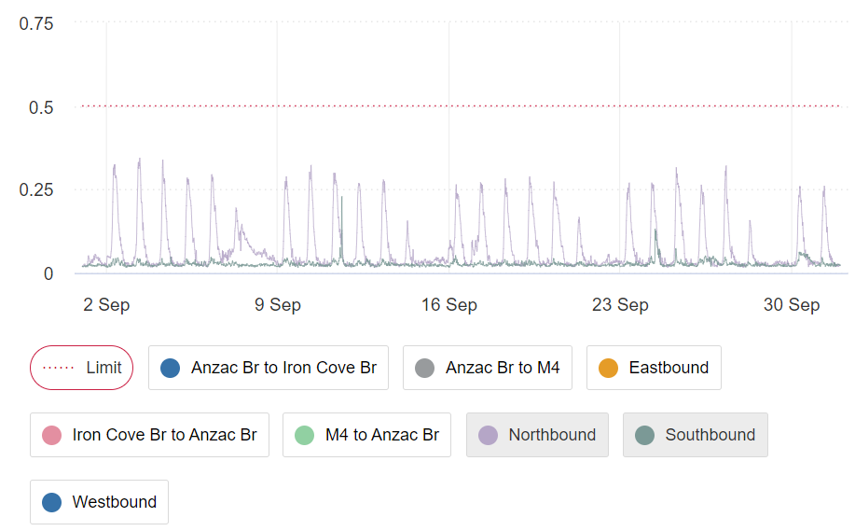

**Ambient (NO2 1 hour average)**

**Albert Street and Campbell Street:**

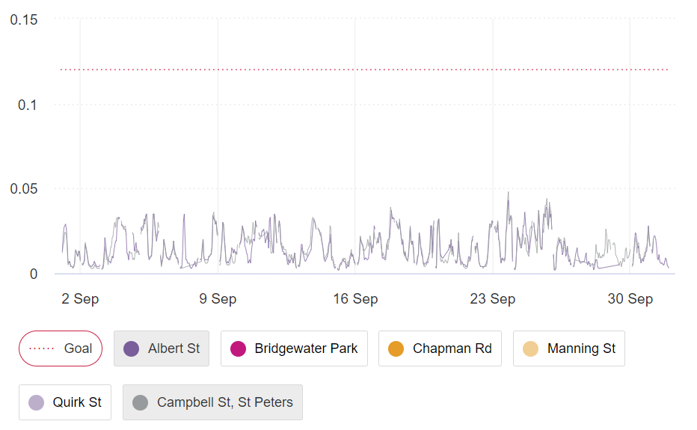

**Ramsay Street and Wattle Street:**

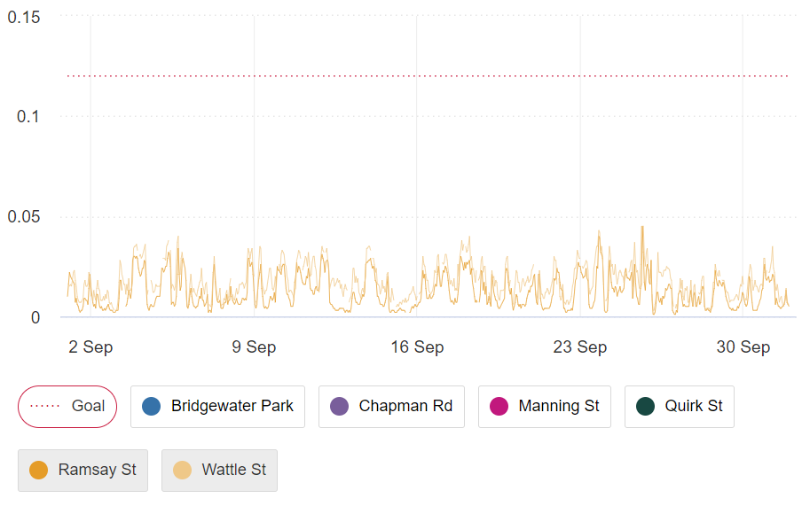

**Ventilation Outlet (NO2 1 hour average)**

**Parramatta Road Ventilation Facility:**

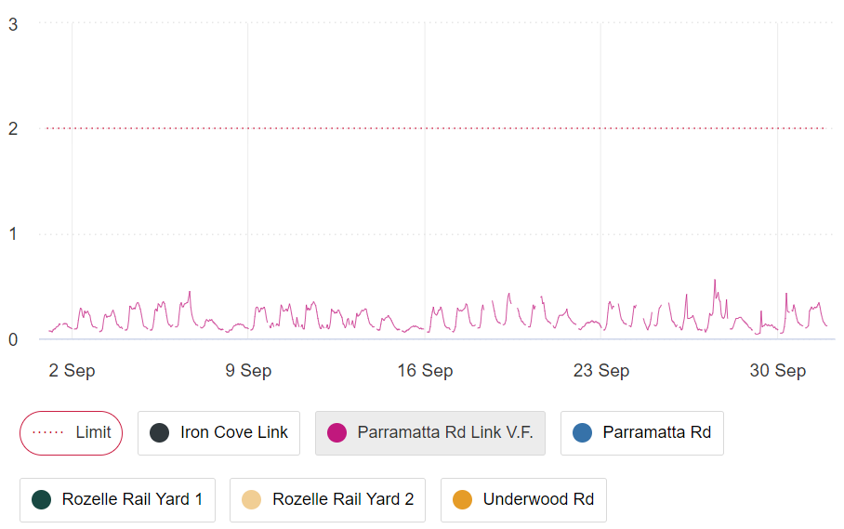

**Campbell Road Ventilation Facility:**

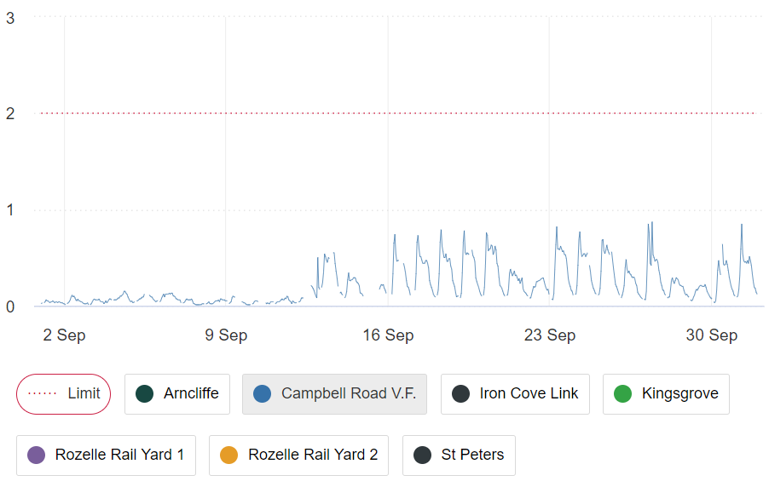

***The data reflected in this document has undergone preliminary quality assurance checks. Validated air quality data reports are made available on the*** [***Linkt Environmental and Air Quality Reports***](https://www.linkt.com.au/using-toll-roads/safety/air-quality/sydney) ***wepbage one month after the end of the calendar month.***